LAB #9
Efe Emir Cesur
Student ID #: 22608
Lab Section: A
1. Introduction
In this experiment, the primary objective was to design, simulate, and construct a discrete multistage BJT amplifier that meets specific performance criteria. These specifications included a non-inverting midband voltage gain of 100, high input impedance ($\ge 1 M\Omega$), low output impedance ($\le 100 \Omega$), and a target bandwidth ranging from 20 Hz to 20 kHz. To fulfill these requirements, a multi-stage architecture was utilized. At the input stage, a Darlington pair configuration was chosen to increase the current while keeping the bandwidth constant. The circuit design was first verified through LTSpice simulations to analyze its transient and frequency responses, followed by physical implementation and performance measurement using standard laboratory equipment.
2. Pre-Lab Work
For the pre-lab work, I designed a discrete multistage amplifier that is to meet the specifications:
● Midband voltage gain: Av = 100±15% (non-inverting)
● Lower 3-dB frequency: fL ≤ 20 Hz
● Upper 3-dB frequency: fH ≥ 20 kHz
● Input impedance: |Zin| ≥ 1 MΩ (for 20 ≤ f ≤ 20 kHz)
● Output impedance: |Zo| ≤ 100 Ω (for 20 ≤ f ≤ 20 kHz)
● Output swing range @ 1 kHz input: 2.5 Vpp (without nonlinear distortion)
● Power supply voltages: VCC = +15 V and VEE = -15V.
● Load resistance: RL = 200 Ω
● No DC current flow through signal source or load
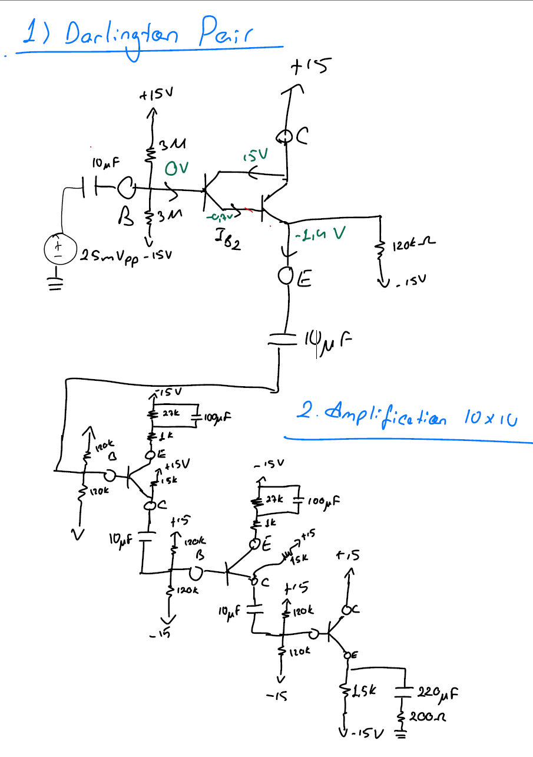
Figure 1: Design of the multistage amplifier.
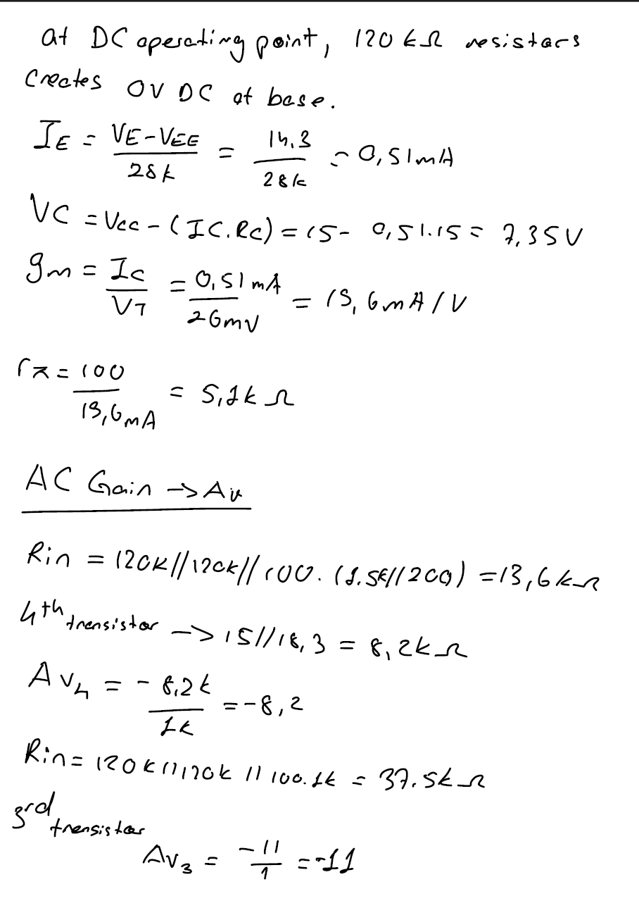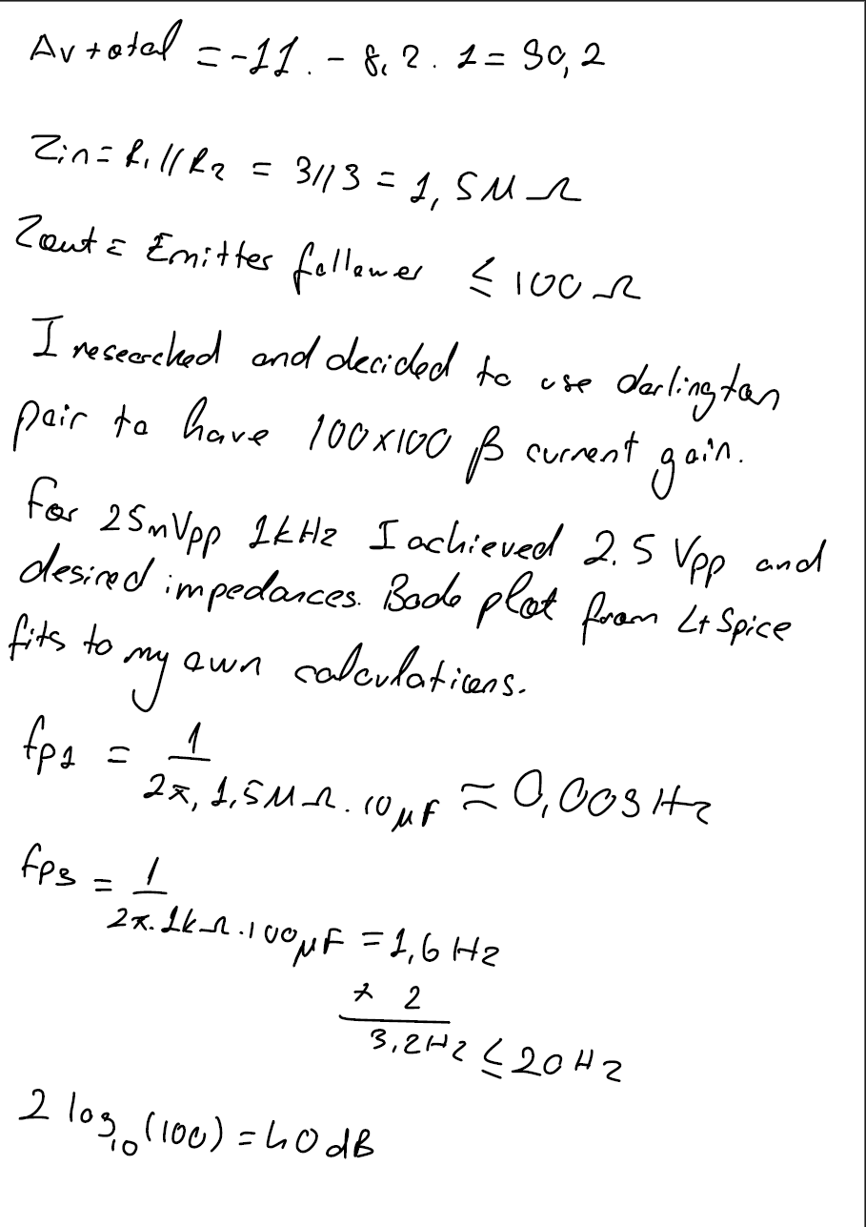
Figure 2 and 3: Hand calculations of the design.
After designing the amplifier using hand calculations, I used LTSpice to simulate AC transfer (Bode Plot), transient (for a sinusoidal small signal at 1 kHz), DC transfer, and input-output impedance characteristics.
Figure 4: Schematic of the circuit in LTSpice.
Figure 5: Currents and Voltages of the nodes of design.
Figure 6: Bode Plot of the schematic.
Figure 7: Input voltage of the schematic.
Figure 8: Output voltage of the schematic.
3. Data/Results
Part 1: Building Input Stage
In the input stage, to find input impedance, I connected R test between Vin and Vtest before my input stage and I connected Rload to the output of stage.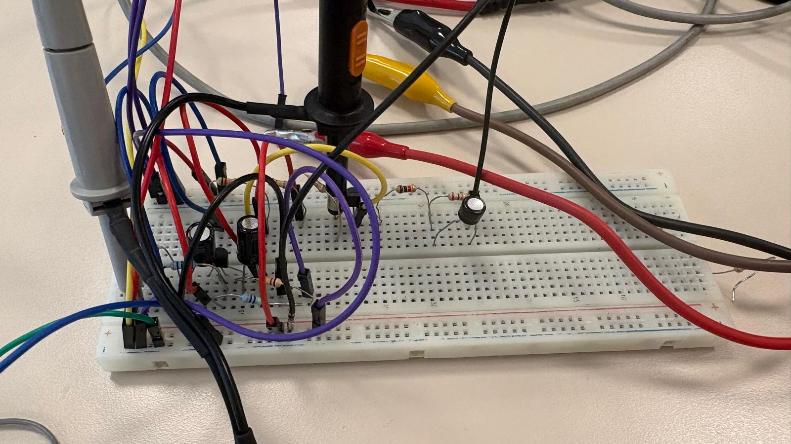
Figure 9: Input stage circuit.
Then I calculated my impedance using formula Rin / (Rin + Rtest) = Vout/Vin which in my case Rin / (Rin + 220k) ohm = 0.9V / 1V which Rin is 2M ohm.
Part 2: The Amplification Stage
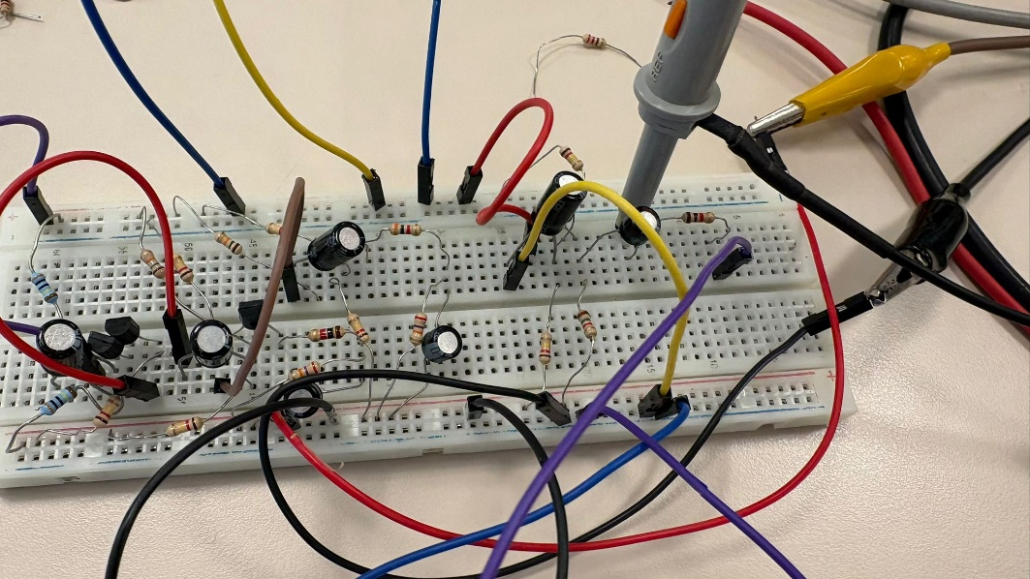
Figure 10: Input and Amplification stages together.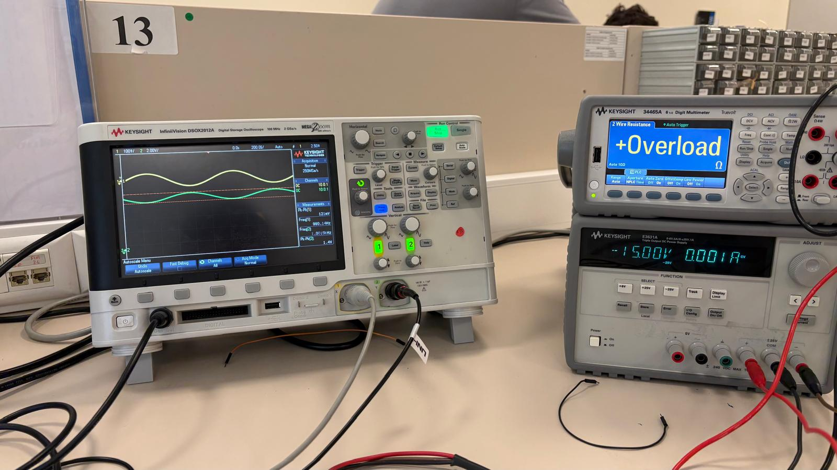
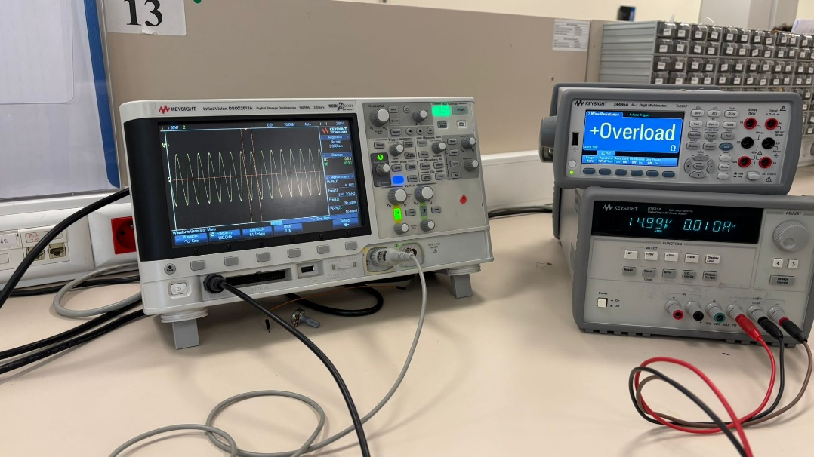
Figure 11 and 12: First and Second Amplification stages.
Part 3: Output Stage
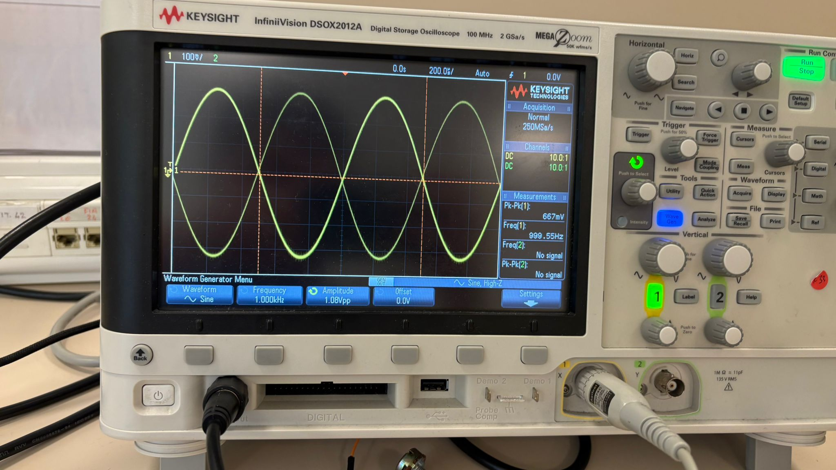
Figure 13: Output Stage Measurements
For the output stage, I connected Rtest, before my Vtest, after the output stage and calculated output impedance using Vx / Vtest = Rout / (Rout+Rtest) which for this circuit, it is found as 130mV / 667mV = Rout / (Rout + 200) = 60 ohm.
Part 4: Whole Circuit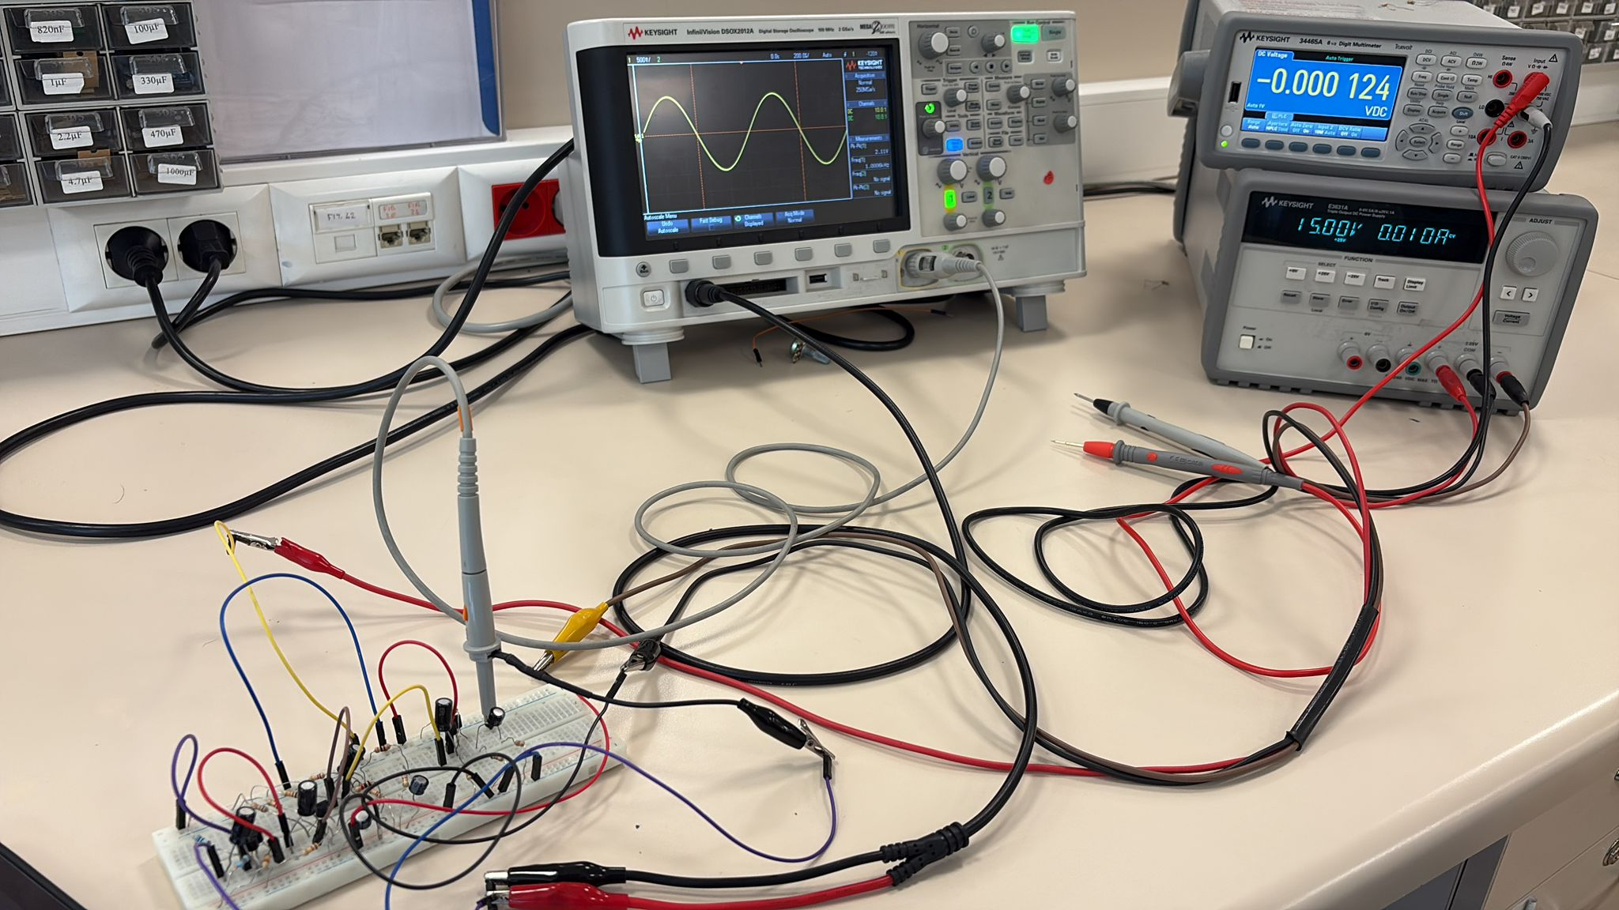
Figure 14: Whole Circuit

4. Discussion / Analysis
The implementation of the multistage amplifier was conducted stage by stage to systematically evaluate the circuit parameters. LTSpice simulations provided the theoretical baseline for the expected midband gain and the 3-dB cutoff frequencies. During the physical testing, the Darlington pair at the input stage successfully provided the required current amplification and high input impedance without degrading the operational bandwidth.
Some variations were observed between the theoretical calculations and the actual experimental measurements. These differences were primarily caused by the inherent tolerances of the physical components, such as variations in the BJT beta values, and the parasitic resistances introduced by the breadboard connections. Furthermore, driving a low load resistance 200 ohm typically causes a significant voltage drop at the output. To resolve this issue and prevent voltage loss, a Darlington pair was also utilized at the output stage. This final configuration minimized the loading effects, allowing the circuit to achieve and deliver a proper, undistorted gain at the output.
5. Conclusion
This laboratory session successfully demonstrated the design principles and practical implementation of a discrete multistage BJT amplifier. The experiment confirmed that utilizing multiple amplifier stages is essential to simultaneously meet strict gain, impedance, and bandwidth requirements. The strategic placement of a Darlington pair at the input stage allowed for increased current without reducing the bandwidth. Similarly, employing a Darlington pair at the output stage successfully prevented voltage loss, ensuring that the target gain was properly obtained and observed across the load. Despite minor performance deviations caused by real-world component tolerances, the experimental results aligned accurately with the theoretical expectations and initial simulations.

